**TankBot Controller Design**

The TankBot controller is comprised of two Arduino microcontrollers. The base is a Leonardo in the DFRobot Romeo V2 board. The Nano 33 BLE is carried on a custom shield board plugged into the Romeo V2. Communications between the two boards is via I2C using a 3.3-5 V level convertor.

The Leonardo controller supports the following devices:

* XBee radio (on-board connector)
* LoRa radio (via SPI)
* BNO055 9 DOF smart IMU via I2C
* Motor power control
* MG995 servo control
* DFRobot URM V5.0 Ultrasonic sensor

The Nano 33 BLE supports the following devices:

* SD card writer (SPI)
* Motor rotation sensors (interrupts Pins 9-12?)

**Leonardo Specs**

Digital – 20 (PWM – 7)

Analog - 12

Flash – 32 KB

SRAM – 2.5 K

Voltage – 5 V

Clock 16 MHz

Pins used:

* 4,5,6,7 - Motor control
* 2,3 – SDA, SCL (I2C) [**LEVEL CONVERTOR**]
* 8 – Servo
* 9,10 – US Trig/Echo (10 TRIG, A0 Voltage sense)
* 11, 12 CE, CSN (SPI)
* 13 – Nano 33 Interrupt [**LEVEL CONVERTOR**]
* 14,15,16 - MISO, SCK, MOSI (SPI)

**Nano 33 BLE Specs**

Digital – 14 (all PWM, all interrupts)

Analog – 8 (12-bit ADC)

Flash – 1 MB

SRAM – 256 KB

Voltage – 3.3 V

Clock 64 MHz

Pins used:

* A4, A5 - SDA, SCL (I2C) [**LEVEL CONVERTOR**]
* 7,8,9,10 – Motor interrupts
* 11, 12, 13 – MOSI, MISO, SCK (SPI)
* 4 – Leonardo interrupt [**LEVEL CONVERTOR**]

The primary ROS controller for the TankBot is a Jetson Nano with 4 GB memory and 128 core GPU. The Nano 33 BLE will be a ROS node and will provide control data to the Leonardo. The design goal is to push as much intelligence as possible to lower levels. For example, if the IMU detects no motion but the motors are powered, the Leonardo may stop the motors and provide an emergency stop notice through the Nano BLE. The Leonardo / Nano BLE may be wired to allow the Leonardo to trigger an interrupt on the Nano BLE to ensure priority servicing. Since the Nano BLE can support TinyML, certain operational aspects (motor stall detect) may involve ML models on the Nano BLE. The Nano BLE may also be used to perform computationally demanding work (e.g., validation of radio packets) instead of running it on the Leonardo.

The Nano BLE will also store debugging data on the 32 GB SD card.

The Nano BLE may also handle lower levels of the communications stack. It is expected that any store-and-forward components of Delay Tolerant Networking (DTN) will be handled on the Jetson Nano, along with the primary ROS functions.

Future versions may support a RTOS (real-time operating system) or micro-ROS on the Nano BLE, but that will not be part of the original design.

**Appendix** – Diagrams and pin assignments

3.3 to 5 V logic convertor

Nano 33 BLE

3.3 V header for Hall

Hall inputs (interrupts)

Ultrasonic Sensor (RomeoV2)

CE / CSN SPI (Romeo V2)

Servo (Romeo V2)

SD / SPI

Headers towards outer edges are connected to Romeo V2 pins / power.

**Pins** (from top of image)

3.3 V header

|  |
| --- |
| 3.3 V |
| GND |

Hall inputs (Nano 33 interrupts)

|  |  |
| --- | --- |
| 10 | Motor L (M1) B |
| 9 | Motor L (M1) A |
| 8 | Motor R (M2) B |
| 7 | Motor R (M2) A |

CE / CSN SPI (Romeo V2) – LoRa Radio

Use Pin 14-16 block for MISO, MOSI, CLK and power

|  |  |
| --- | --- |
| Pin 12 | CSN |
| Pin 11 | CE |

Ultrasonic Sensor URN V5 (PWM mode) (Romeo V2)

|  |  |
| --- | --- |
| GND |  |
| 5V |  |
| Pin 9 | Echo |
| Pin 10 | Trig |

Servo (Romeo V2)

|  |
| --- |
| GND |
| 5V |
| Pin 8 |

SD / SPI

|  |  |
| --- | --- |
| N/A |  |
| SCK | 13 |
| MOSI | 11 |
| MISO | 12 |
| 3.3 V |  |
| GND |  |

Nano 33 BLE pinouts / SD card / BNO055 IMU

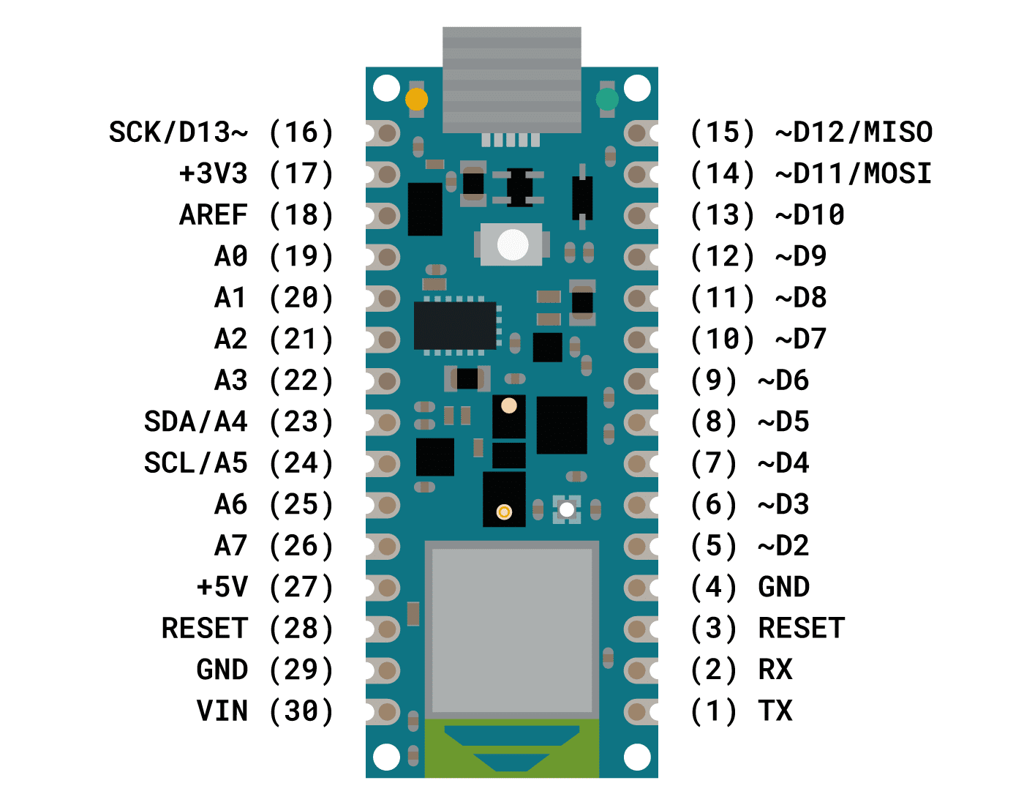

Hall effect motor sensor

